What is UEFI Shell?

UEFI Shell is an application. It’s an Extensive Standardized Pre-OS UEFI Application.

We boot to UEFI Shell rather than OS. Its exactly fits in between Boot Manager and OS.

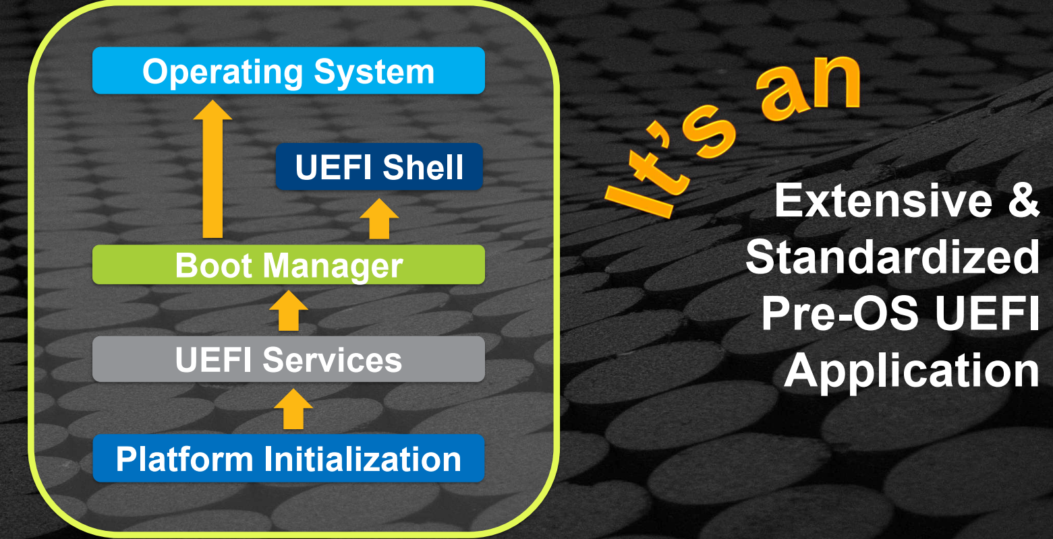

UEFI Shell Elements:

* Small Size Profiles
* Shell Commands
* New Shell API
* Enhanced Scripting

Small Size Profiles:

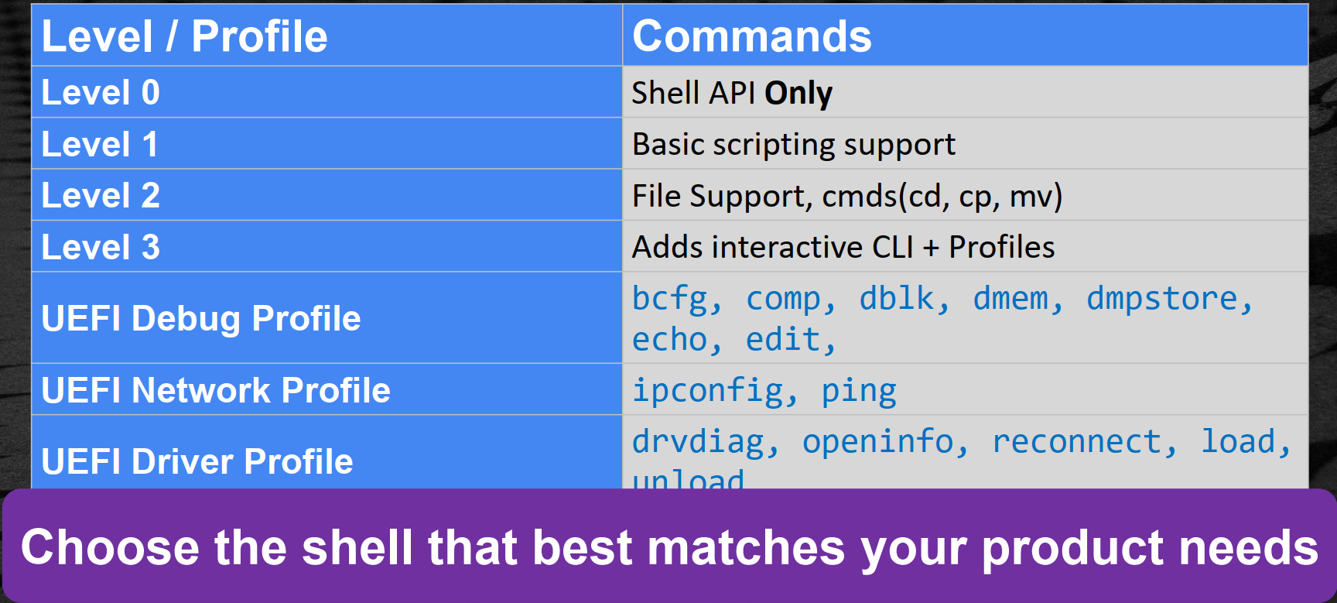

Shell Commands:

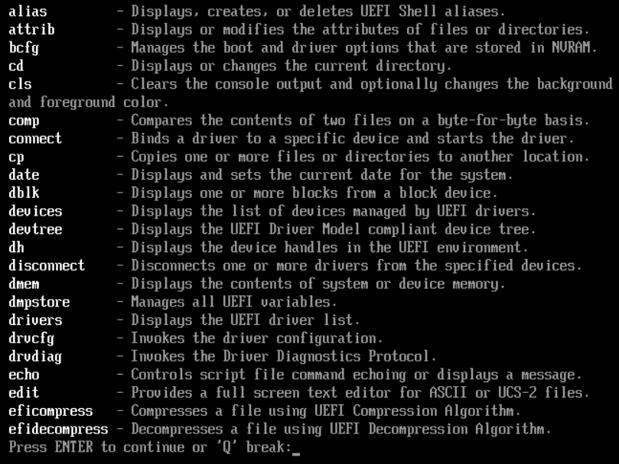

Shell API:

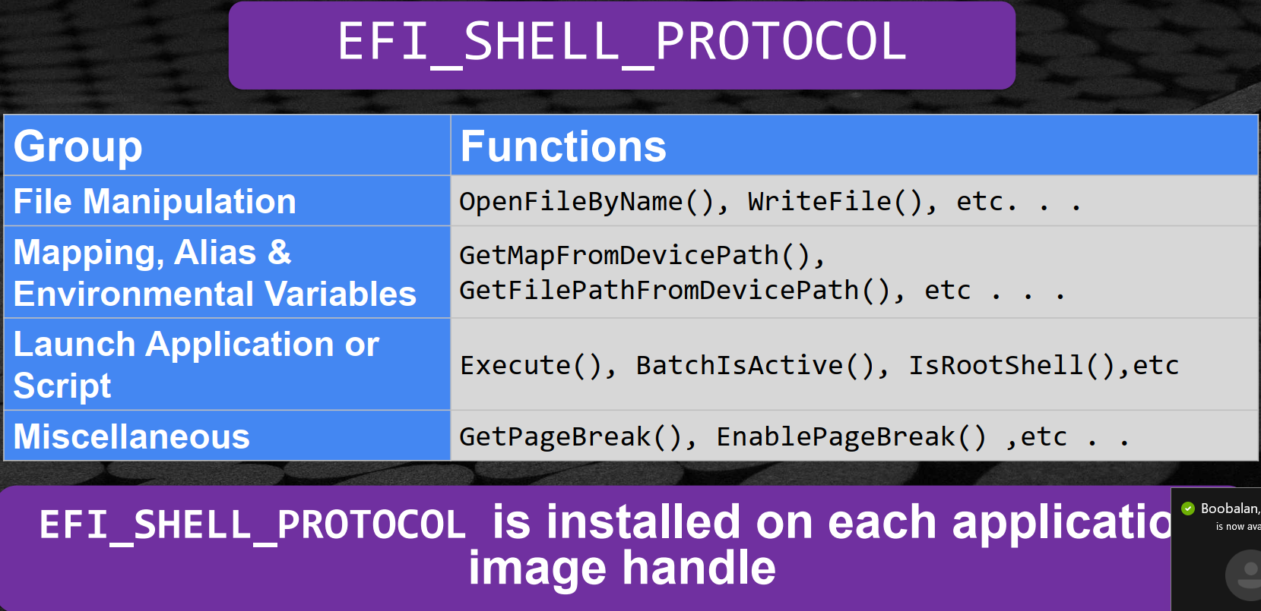

Shell APIs are in ShellPkg.

gEFIShellParametersProtocol

gEFIShellProtocol

Enhanced Scripting:

* Contains .nsh extension
* “Startup.nsh” Runs first.
* Supports:
  + Command line arguments
  + Standard script arguments
  + Input and output redirection & pipes

Accessing the shell:

EFI/boot/BOOTx64/.efi = OS loader, UEFI application, or UEFI Shell